Task 2: Data Retrieval & Sorting Dashboard
Aim: To design and develop a dashboard that retrieves student records from a database, allows sorting by name or date, filtering by department, and displays the count of students in each department using SQL queries.
Algorithm:
- Start the program
- Connect to the database
- Get input for sorting (name or date)
- Get input for filtering (department)
- Construct SQL query using sorting and filtering conditions
- Retrieve data from the database
- Display records in table format
- Count students in each department using GROUP BY
- Display count result
- Stop the program
Program:
Db.php:
<?php
$conn = new mysqli("localhost", "root", "", "student_db");
if ($conn->connect_error) {
die("Connection failed: " . $conn->connect_error);
}
?>
dashboard.php:
<?php
include 'db.php';
// Sorting
$order = "";
if (isset($_GET['sort'])) {
if ($_GET['sort'] == "name") {
$order = "ORDER BY name ASC";
} elseif ($_GET['sort'] == "dob") {
$order = "ORDER BY dob ASC";
}
}
// Filtering
$where = "";
if (isset($_GET['department']) && $_GET['department'] != "") {
$dept = $_GET['department'];
$where = "WHERE department='$dept'";
}
// Fetch student data
$sql = "SELECT * FROM students $where $order";
$result = $conn->query($sql);
// Count per department
$count_sql = "SELECT department, COUNT(*) as total FROM students GROUP BY department";
$count_result = $conn->query($count_sql);
?>
<!DOCTYPE html>
<html>
<head>
<title>Student Dashboard</title>
<style>
body {
font-family: Arial;
background-color: #f2f2f2;
}
.container {
width: 80%;
margin: auto;
background: white;
padding: 20px;
}
table {
width: 100%;
border-collapse: collapse;
margin-top: 20px;
}
th, td {
padding: 10px;
border: 1px solid black;
}
button, select {
padding: 8px;
margin: 5px;
}
</style>
</head>
<body>
<div class="container">
<h2>Student Dashboard</h2>
<!-- Sorting Buttons -->
<a href="?sort=name"><button>Sort by Name</button></a>
<a href="?sort=dob"><button>Sort by DOB</button></a>
<!-- Filter Form -->
<form method="GET">
<select name="department">
<option value="">All Departments</option>
<option>CSE</option>
<option>ECE</option>
<option>EEE</option>
<option>MECH</option>
</select>
<button type="submit">Filter</button>
</form>
<!-- Student Table -->
<table>
<tr>
<th>ID</th>
<th>Name</th>
<th>Email</th>
<th>DOB</th>
<th>Department</th>
<th>Phone</th>
</tr>
<?php while($row = $result->fetch_assoc()) { ?>
<tr>
<td><?php echo $row['id']; ?></td>
<td><?php echo $row['name']; ?></td>
<td><?php echo $row['email']; ?></td>
<td><?php echo $row['dob']; ?></td>
<td><?php echo $row['department']; ?></td>
<td><?php echo $row['phone']; ?></td>
</tr>
<?php } ?>
</table>
<!-- Department Count -->
<h3>Department-wise Student Count</h3>
<table>
<tr>
<th>Department</th>
<th>Total Students</th>
</tr>
<?php while($row = $count_result->fetch_assoc()) { ?>
<tr>
<td><?php echo $row['department']; ?></td>
<td><?php echo $row['total']; ?></td>
</tr>
<?php } ?>
</table>
</div>
</body>
</html>
Database:
CREATE DATABASE student_db;
USE student_db;
CREATE TABLE students (
id INT AUTO_INCREMENT PRIMARY KEY,
name VARCHAR(100),
email VARCHAR(100),
dob DATE,
department VARCHAR(50),
phone VARCHAR(15)
);

OUTPUT:
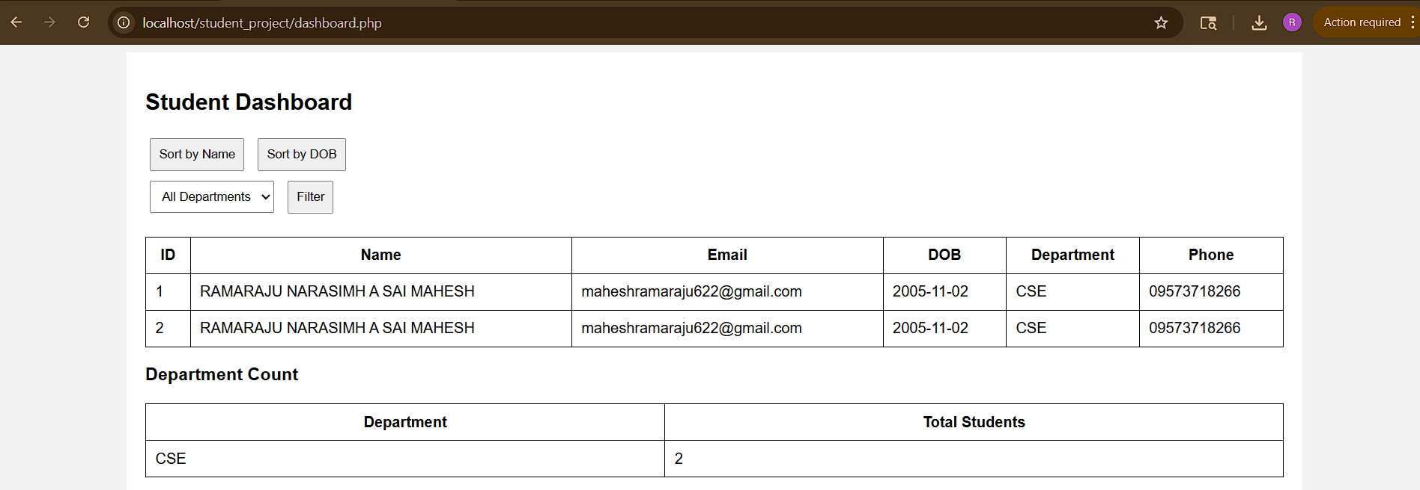

Result: Thus, student dashboard has been created successfully and output is generated.

